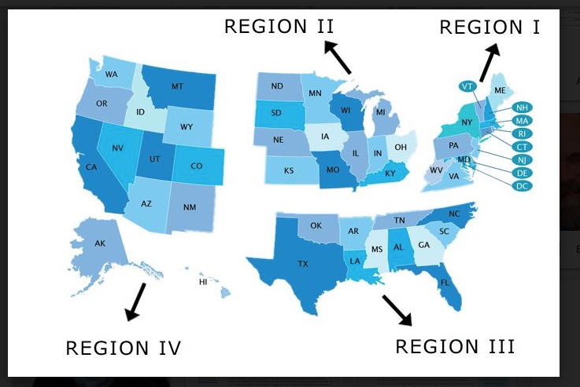
Region 1
G.U Department of Education
- Bilingual licensure for Deaf Ed. (K-12) Teachers, not ASL Teachers
– MASLED (World Language) – MA+ with 30 credits – Ed.s can get licensure for ASL teaching.

Massachusetts
– Teacher of the Deaf - ASL /TC –(Total Communications) Licensure (K-12) for all Levels with SLPI score at intermediate level
– can take some tests for World Language Licensure (not sure what kind of tests

Rochester, New York
– MSSE (NTID) – Secondary Ed. in Deaf Ed.

Pennsylvania
– Bloomburg and University of Pittsburgh (Deaf Ed.)

Region 2
Iowa
– World Language – culture, linguistics , etc classes, must be Teacher of the Deaf

Indiana
– Teacher License, Masters in Deaf Ed.

Michigan
– Masters in Deaf Ed.

Minnesota
– Masters in Deaf Ed. , MASLED, must take four tests; Pedogogy 1,2 Math, ASLPI ( Minnesota’s own)

Kansas
- Whole Language
- Professional teaching license (early childhood, elementary, secondary) with or without endorsements (content area, deaf education, special education, education administration, etc.)

Ohio
– Whole Language, 2018 will add ASL Test

Region 3
Arkansas
– Praxis in ASL (Whole Language)
- Professional teaching license (early childhood, elementary, secondary) with or without endorsements (content area, deaf education, special education, education administration, etc.)

South Carolina, Florida, Alabama, Texas
– Teacher Certification = in ASL endorsement

Louisiana
– Deaf Ed. – ASLTA Certification

Texas
– TASC – ASL Certification

Georgia
– GACE – ASL Certification – (Required prequalified test – Basic Skills and Deaf Education GACE)

Region 4
Washington State
– For Whole Language , no for CTE – need more information
– DK but no ASL – West B

California
- CSET + CBEST (for Deaf School) (HC) - included music, dance, not related to ASL
- CSET ASL for (Whole Language or Heritage Language) no --- ? outdated
– RICA for BLA – no --? (test focus on Audiology and Vocal + inconsistency)
– BLCAD (UCSD primarily graduates – yes

Oregon
- Professional Teaching License – yes

Utah
- ASL Whole Language Creds Test

Utah, California, Arizona
- DHHS ed. Specialist (test focus on Audiology and Vocal + inconsistency)
California , Oregon
ASLPI (Score of 3+) - yes

Washington
- ASLPI (Score of 4+) – yes

